How to transfer the data from child to parent
and from parent to another child?

What we have : User, UserForm and UserTable

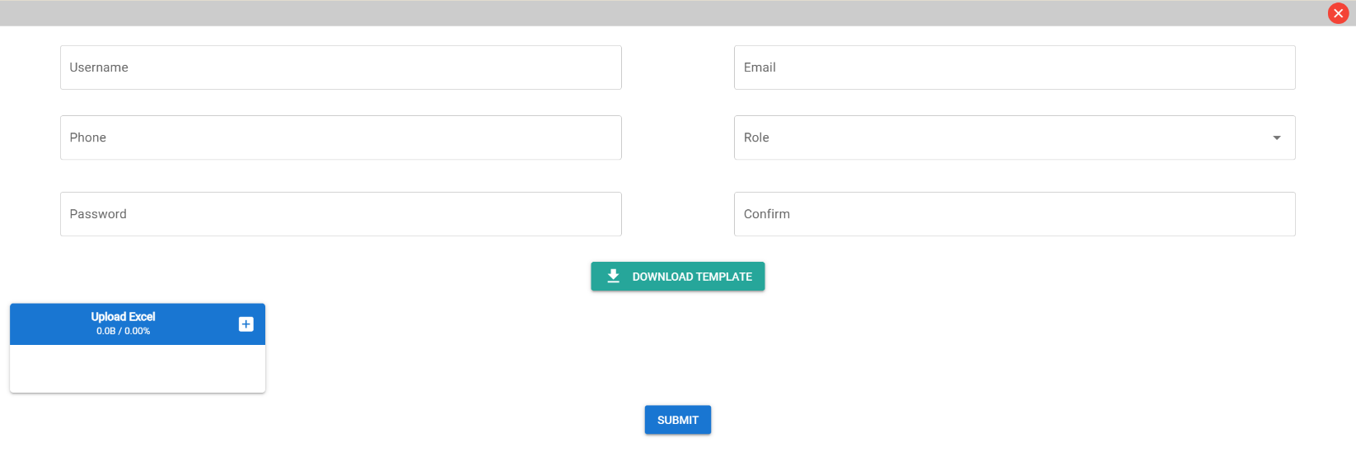
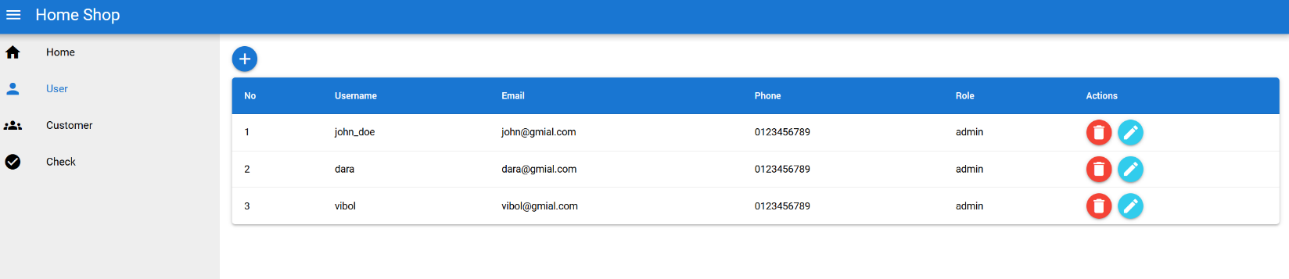
Figure 1UserTable
Figure 2User and User Table

- User and UserTable

When click on add it will show the dialog to UserTable to input the data. Therefore we start from add button:

<q-btn dense icon="add" color="primary" round class="q-mb-sm" @click="handleAdd" >

When they click on the add button it will called function : handleAdd

handleAdd() { this.dialog = true;}, then it will open the UserTable :

<q-dialog
v-model="dialog"
persistent
:maximized="true"
transition-show="slide-up"
transition-hide="slide-down"
>
<q-card class="bg-white">
<q-bar>
<q-space />
<q-btn
dense
flat
icon="close"
class="text-white bg-red"
@click="dialog = false"
round
>
<q-tooltip class="bg-white text-primary">Close (ESC)</q-tooltip>
</q-btn>
</q-bar>

<user-form @batch-import="handleBatchImport" @submit="handleSubmit" />

</q-card>
</q-dialog>

- UserTable

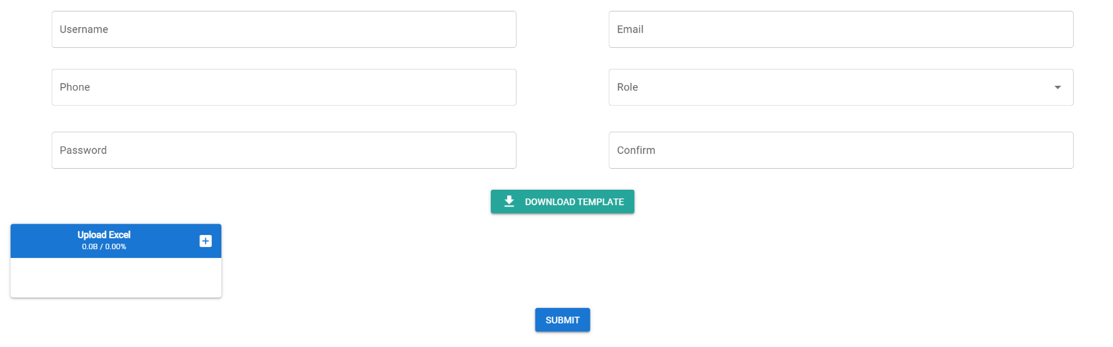

After they fill the form they will click on the submit button :

<div class="q-ma-md text-center">
<q-btn
:color="updateDoc ? 'info' : 'primary'"
:label="updateDoc ? 'Update' : 'Submit'"
@click="handleSubmit"
>
<q-tooltip class="bg-white text-primary">(Ctrl + S)</q-tooltip>
</q-btn>
</div>

Explain: <q-tooltip class="bg-white text-primary">(Ctrl + S)</q-tooltip> is the quasar mouse over then it will show the message

When they click submit will called function : handleSubmit

handleSubmit() {
this.$emit("submit", { doc: this.form, source: "manual" });

if (this.form.password === this.confirm && this.form.password != null) {
if (this.reset) {
this.form.reset = this.reset;
}
}

if (this.updateDoc) {
// code update
}

this.$emit("close");
},

Explain : this.$emit("submit", { doc: this.form, source: "manual" });

-this.$emit : is the vue that use for transfter the data to parent UserForm: and they emit
object: { doc: this.form, source: "manual" } : one is from that they fill and the source is string manual.

ចឹងយើងបោះទៅនឹងយើងយកវាទៅដាក់នៅកន្លែងណាដែលយើងចង់អោយ វាទទួលទិន្នន័យដោយត្រូវដាក់ Our custom event យើងនឹង @submit

- In the User we have dialog to keep the UserTable component :

<user-form @batch-import="handleBatchImport" @submit="handleSubmit" />

- In User Table: កន្លែងដែលយើងចាប់យក Data

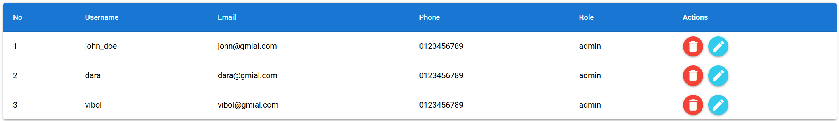

In Vue.js, props stands for "properties" — they are a mechanism for passing data from a parent component to a child component.

props: {
users: {
type: Array, // The expected data type is an array
default: null, // If no value is passed, it defaults to null
required: true // This prop must be provided by the parent
}
}

Therefore we can get the data from UserForm to the UserTable. To display the data we use v-for :

<tbody>
<tr v-for:="(user, index) in users" :key="index">
<td class="text-left">{{ index+1 }}</td>
<td class="text-left">{{user.username}}</td>
<td class="text-left">{{user.email}}</td>
<td class="text-left">{{user.phone}}</td>
<td class="text-left">{{user.role}}</td>
<td class="text-left">
<q-btn
color="red"
dense
icon="delete"
round
@click="handleDelete(user._id)"
/>
<q-btn
color="info"
dense
icon="edit"
class="q-ml-sm"
round
@click="habndleEdit(user)"
/>
</td>
</tr>
</tbody>

